#### A PROJECT REPORT

on

#### “DRIVER DROWSINESS DETECTION SYSTEM”

Submitted to

### G.L. BAJAJ INSTITUTE OF TECHNOLOGY AND MANAGEMENT

In Fulfillment of the Requirement for the Award of

### BACHELOR’S DEGREE IN COMPUTER SCIENCE &

ENGINEERING

#### BY

JAY MISHRA HIMANSHU JAIN HARSH BHAGWANI

#### ROLL NO:1901920100134 ROLL NO:1901920100123 ROLL NO:1901920100112

UNDER THE GUIDANCE OF PROF. SATENDRA KUMAR

#### G.L. BAJAJ INSTITUTE OF TECHNOLOGY AND MANAGEMENT

G.B. NAGAR,GREATER NOIDA-201310

December 2020

G.L. BAJAJ INSTITUTE OF TECHNOLOGY AND MANAGEMENT [1]

G.L. BAJAJ INSTITUTE OF TECHNOLOGY AND MANAGEMENT

G.B.Nagar,Greater Noida, U.P.- 201310

## CERTIFICATE

This is certify that the project entitled

#### “Driver Drowsiness Detection System“

Submitted by

JAY MISHRA HIMANSHU JAIN HARSH BHAGWANI

ROLL NUMBER:19019210100134 ROLL NUMBER :1901920100123 ROLL NUMBER:1901920100112

is a record of bonafide work carried out by them, in the partial fulfilment of the requirement for the award of Degree of Bachelor of Engineering (Computer Sci- ence & Engineering ) at G.L. Bajaj Institute Of Technology and Management,Greater Noida. This work is done during year 2020-2021, under our guidance.

Date:

(Prof. Satendra Kumar)

Project Guide

Acknowledgements

We are profoundly grateful to Prof. SATENDRA KUMAR for his expert guidance and continuous encouragement throughout to see that this project rights its target since its commencement to its completion. .....................

JAY MISHRA HIMANSHU JAIN HARSH BHAGWANI

G.L. BAJAJ INSTITUTE OF TECHNOLOGY AND MANAGEMENT [3]

### ABSTRACT

This document is a review report on the research conducted and the project made in the field of computer engineering to develop a system for driver drowsiness detection to prevent accidents from happening because of driver fatigue and sleepiness. The report proposed the results and solutions on the limited implementation of the various techniques that are introduced in the project. Whereas the implementation of the project give the real world idea of how the system works and what changes can be done in order to improve the utility of the overall system.

Furthermore, the paper states the overview of the observations made by the authors in order to help further optimization in the mentioned field to achieve the utility at a better efficiency for a safer road.

**Keywords**—Driver drowsiness; eye detection; yawn detection; blink pattern; fatigue

|  |  |  |  |
| --- | --- | --- | --- |
| 1 | Introduction | | 8 |
|  | 1.1 | PURPOSE . . . . . . . . . . . . . . . . . . . . . . . . . . . | 8 |
|  |  | 1.1.1 HUMAN PSYCHOLOGY. . . . . . . . . . . . | 8 |
|  |  | 1.1.2 CURRENT STATISTICS . . . . . . . . . . . . . . . . . . . | 9 |
|  | 1.2 | DOCUMENT CONVENTIONS . . . . . . . . . . . . . . . . | 9 |
|  | 1.3 | INTENDED AUDIENCE. . . . . . . . . . . . . . . | 9 |
|  | 1.4 | PRODUCT SCOPE. . . . . . . . . . . . . . . | 10 |
|  | 1.5 | PROBLEM DEFINITION. . . . . . . . . . . . . . . | 10 |
| 2 | Literature Survey | | 11 |
|  | 2.1 | SYSTEM REVIEW . . . . . . . . . . . . . . . . . . . . . . . . . . . | 11 |
|  | 2.2 | TECHNOLOGY USED. . . . . . . . . . . . . . . | 11 |
| 3 | Software Requirements Specification | | 12 |
|  | 3.1 | PYTHON . . . . . . . . . . . . . . . . . . . . . . . . . . . | 12 |
|  |  | 3.1.1 LIBRARIES . . . . . . . . . . . . . . . . . . . . | 12 |
|  | 3.2 | OPERATING SYSTEM . . . . . . . . . . . . . . . . . . . . . . . . . . . | 12 |
|  | 3.3 | HARDWARE . . . . . . . . . . . . . . . . . . . . . . . . . . . | 12 |
| 4 | Requirement Analysis | | 13 |
|  | 4.1 | PYTHON . . . . . . . . . . . . . . . . . . . . . . . . . . . | 13 |
|  |  | 4.1.1 LIBRARIES . . . . . . . . . . . . . . . . . . . . | 13 |
|  | 4.2 | OPERATING SYSTEM . . . . . . . . . . . . . . . . . . . . . . . . . . . | 13 |
|  | 4.3 | HARDWARE . . . . . . . . . . . . . . . . . . . . . . . . . . . | 13 |
|  |  | 4.3.1 LAPTOP . . . . . . . . . . . . . . . . . . . . | 13 |
|  |  | 4.3.2 WEBCAM . . . . . . . . . . . . . . . . . . . . | 13 |
| 5 | System Design | | 14 |
|  | 5.1 | USE CASE MODEL . . . . . . . . . . . . . . . . . . . . . . . . . . . | 14 |
|  | 5.2 | ACTIVITY DIAGRAM . . . . . . . . . . . . . . . . . . . . . . . . . | 15 |
| 1 | 5.3 | CLASS DIAGRAM . . . . . . . . . . . . . . . . . . . . . . . . . | 16 |
| 6 | System Testing | | 17 |
|  | 6.1 | TEST CASES & TEST RESULTS . . . . . . . . . . . . . . . . . . . . . . | 17 |

|  |  |  |  |
| --- | --- | --- | --- |
| 7 | Project Planning | | 18 |
|  | 7.1 | SYSTEM MODEL . . . . . . . . . . . . . . . . . . . . . . . . . . . . . . | 18 |
| 8 | Drver Drowsiness Detection System | | 19 |
|  | 8.1 About the Python Project …………………………………. | | 20 |
|  | 8.2 The Dataset…………………………………………………. | | 20 |
|  | 8.3 The Model Architecture…………………………………….. | | 21 |
|  | 8.4 Algorithm……………………………………………………. | | 22 |
| 9 | Screenshots of Project | | 23 |
|  | 9.1 | NON-DROWSY STATE . . . . . . . . . . . . . . . . . . . . . . . . . . . | 23 |
|  | 9.2 | DROWSY STATE . . . . . . . . . . . . . . . . . . . . . . . . . . . | 23 |
| 10 | Conclusion and Future Scope | | 24 |
|  | 10.1 | CONCLUSION . . . . . . . . . . . . . . . . . . . . . . . . . . . . . . | 24 |
|  | 10.2 | FUTURE SCOPE . . . . . . . . . . . . . . . . . . . . . . . . . . . . . . | 24 |

|  |  |
| --- | --- |
| 11 References | 25 |

|  |  |  |
| --- | --- | --- |
| 5.1 | USE CASE MODEL . . . . . . . . . . . . . . . . . . . . . . . . . . . | 14 |
| 5.2 | ACTIVITY DIAGRAM . . . . . . . . . . . . . . . . . . . . . . . . . | 15 |
| 5.3 | CLASS DIAGRAM . . . . . . . . . . . . . . . . . . . . . . . . . | 16 |
| 5.3 | BLOCK DIAGRAM . . . . . . . . . . . . . . . . . . . . . . . . . | 18 |

# Chapter 1

## Introduction

#### PURPOSE

* + 1. HUMAN PSYCHOLOGY WITH CURRENT TECHNOLOGY

Humans have always invented machines and devised techniques to ease and protect their lives, for mundane activities like traveling to work, or for more interesting purposes like aircraft travel. With the advancement in technology, modes of transportation kept on advancing and our dependency on it started increasing exponentially. It has greatly affected our lives as we know it. Now, we can travel to places at a pace that even our grandparents wouldn’t have thought possible. In modern times, almost everyone in this world uses some sort of transportation every day. Some people are rich enough to have their own vehicles while others use public transportation. However, there are some rules and codes of conduct for those who drive irrespective of their social status. One of them is staying alert and active while driving.

Neglecting our duties towards safer travel has enabled hundreds of thousands of tragedies to get associated with this wonderful invention every year. It may seem like a trivial thing to most folks but following rules and regulations on the road is of utmost importance. While on road, an automobile wields the most power and in irresponsible hands, it can be destructive and sometimes, that carelessness can harm lives even of the people on the road. One kind of carelessness is not admitting when we are too tired to drive. In order to monitor and prevent a destructive outcome from such negligence, many researchers have written research papers on driver drowsiness detection systems. But at times, some of the points and observations made by the system are not accurate enough. Hence, to provide data and another perspective on the problem at hand, in order to improve their implementations and to further optimize the solution, this project has been done.

* + 1. FACTS & STATISTICS

Our current statistics reveal that just in 2015 in India alone, 148,707 people died due to car related accidents. Of these, at least 21 percent were caused due to fatigue causing drivers to make mistakes. This can be a relatively smaller number still, as among the multiple causes that can lead to an accident, the involvement of fatigue as a cause is generally grossly underestimated. Fatigue combined with bad infrastructure in developing countries like India is a recipe for disaster. Fatigue, in general, is very difficult to measure or observe unlike alcohol and drugs, which have clear key indicators and tests that are available easily. Probably, the best solutions to this problem are awareness about fatigue-related accidents and promoting drivers to admit fatigue when needed. The former is hard and much more expensive to achieve, and the latter is not possible without the former as driving for long hours is very lucrative.

When there is an increased need for a job, the wages associated with it increases leading to more and more people adopting it. Such is the case for driving transport vehicles at night. Money motivates drivers to make unwise decisions like driving all night even with fatigue. This is mainly because the drivers are not themselves aware of the huge risk associated with driving when fatigued. Some countries have imposed restrictions on the number of hours a driver can drive at a stretch, but it is still not enough to solve this problem as its implementation is very difficult and costly.

#### DOCUMENT CONVENTIONS

Main Heading Font size: 24 (bold fonts) Sub-headings Font size: 16 (bold fonts)

Sub-headings Content Font size: 14 (normal fonts)

#### INTENDED AUDIENCE

The intended audience for this document are the development team, the project evaluation jury, and other tech-savvy enthusiasts who wish to further work on the project.

#### PRODUCT SCOPE

There are many products out there that provide the measure of fatigue level in the drivers which are implemented in many vehicles. The driver drowsiness detection system provides the similar functionality but with better results and additional benefits. Also, it alerts the user on reaching a certain saturation point of the drowsiness measure.

#### PROBLEM DEFINITION

Fatigue is a safety problem that has not yet been deeply tackled by any country in the world mainly because of its nature. Fatigue, in general, is very difficult to measure or observe unlike alcohol and drugs, which have clear key indicators and tests that are available easily. Probably, the best solutions to this problem are awareness about fatigue-related accidents and promoting drivers to admit fatigue when needed. The former is hard and much more expensive to achieve, and the latter is not possible without the former as driving for long hours is very lucrative.

# Chapter 2

## Literature Survey

#### SYSTEM REVIEW

This survey is done to comprehend the need and prerequisite of the general population, and to do as such, we went through different sites and applications and looked for the fundamental data. Based on these data, we made an audit that helped us get new thoughts and make different arrangements for our task. We reached the decision that there is a need of such application and felt that there is a decent extent of progress in this field too.

#### TECHNOLOGY USED

1. PYTHON - Python is an interpreted, high-level, general-purpose programming language. Python's design philosophy emphasizes code readability with its notable use of significant whitespace.Python is dynamically typed AND supports multiple programming paradigms, including procedural, object-oriented, and functional programming.
2. COMMAND PROMPT - Command Prompt is a command line interpreter application available in most Windows operating systems. It's used to execute entered commands. Most of those commands automate tasks via scripts and batch files, perform advanced administrative functions, and troubleshoot or solve certain kinds of Windows issues.
3. IMAGE PROCESSING - In [computer science](https://en.wikipedia.org/wiki/Computer_science), digital image processing is the use of computer [algorithms](https://en.wikipedia.org/wiki/Algorithm) to perform image processing on [digital](https://en.wikipedia.org/wiki/Digital_image) [images](https://en.wikipedia.org/wiki/Digital_image).
4. MACHINE LEARNING-Machine learning is the [scientific](https://en.wikipedia.org/wiki/Branches_of_science) [study](https://en.wikipedia.org/wiki/Branches_of_science) of [algorithms](https://en.wikipedia.org/wiki/Algorithm) and [statistical models](https://en.wikipedia.org/wiki/Statistical_model) that [computer systems](https://en.wikipedia.org/wiki/Computer_systems) use in order to perform a specific task effectively without using explicit instructions, relying on patterns and inference instead. Machine learning algorithms build a [mathematical model](https://en.wikipedia.org/wiki/Mathematical_model) based on sample data, known as "[training](https://en.wikipedia.org/wiki/Training_data) [data](https://en.wikipedia.org/wiki/Training_data)", in order to make predictions or decisions .

# Chapter 3

## Software Requirements Specification

#### Python:

* Python 3

#### Libraries

* OpenCV
* Tensorflow
* Keras
* Pygame
* Numphy,etc.

#### Operating System

* Windows or Ubuntu

## Hardware Requirements Specification

* + 1. Laptop with basic hardware.
    2. Webcam

**Chapter 4**

Requirement Analysis

* 1. Python: Python is the basis of the program that we wrote. It utilizes many of the python libraries.
  2. Libraries:
* Numpy: Pre-requisite for Dlib
* Tensorflow:Performs backend operations.
* Pygame: Used for sounding the alarm
* Keras:To build our classification model.
* Imutils: Convenient functions written for Opencv.
* Opencv: Used to get the video stream from the webcam, etc.
  1. OS: Program is tested on Windows 10 build 1903 and PopOS 19.04
  2. Laptop: Used to run our code.
  3. Webcam: Used to get the video feed.

# Chapter 5

## System Design

#### USE CASE DIAGRAM

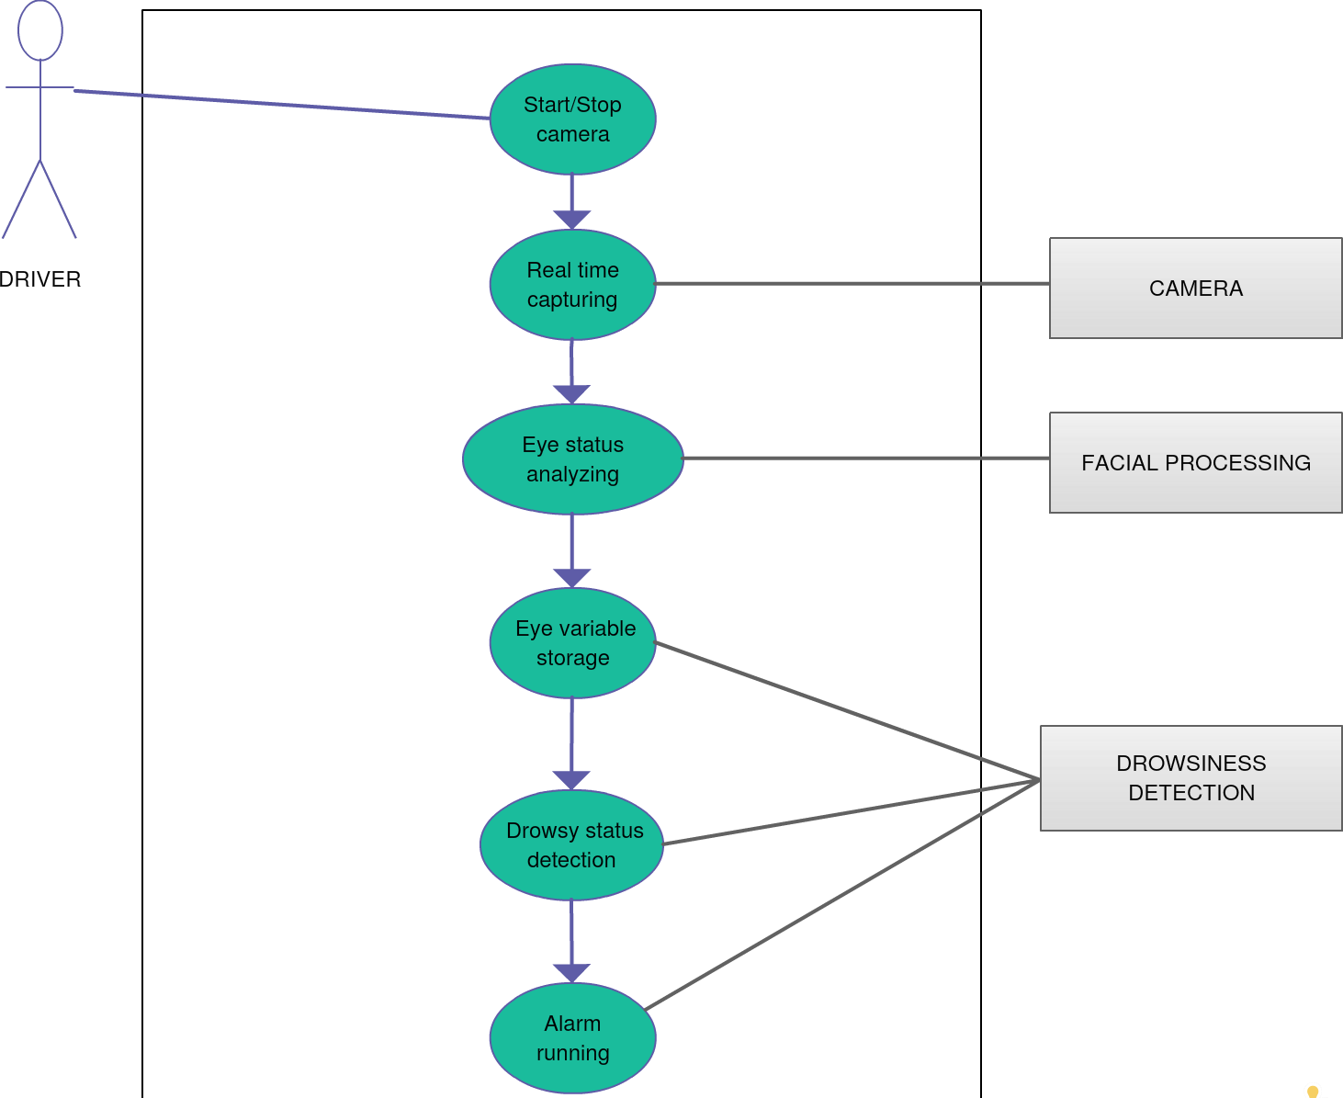

FIGURE 1

#### ACTIVITY DIAGRAM

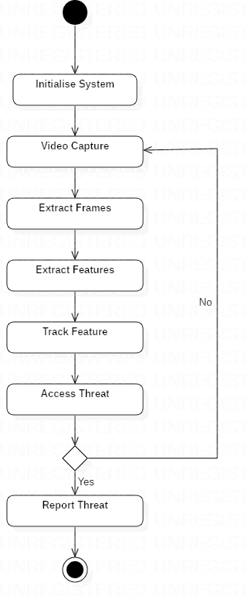

FIGURE 2

#### CLASS DIAGRAM

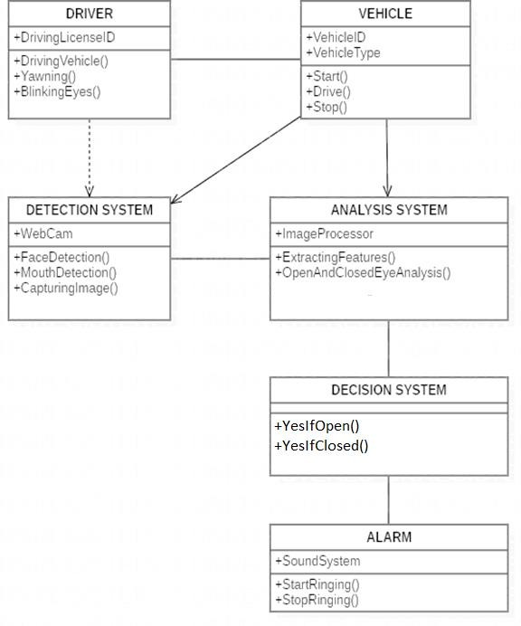

FIGURE 3

# Chapter 6

## System Testing

6.1 Test Cases and Test Results

|  |  |  |  |  |
| --- | --- | --- | --- | --- |
| Test | Test Case Title | Test Condition | System Behavior | Expected Result |
| ID |
| T01 | NSGY | Straight Face, Good Light | Open | Open |
| T02 | YTGN | Straight Face, Good Light, | Closed | Closed |

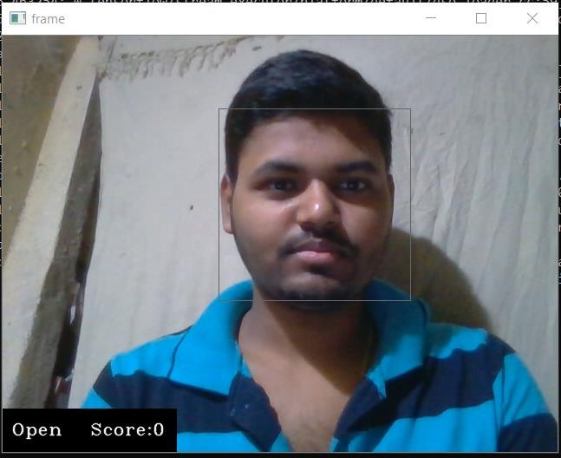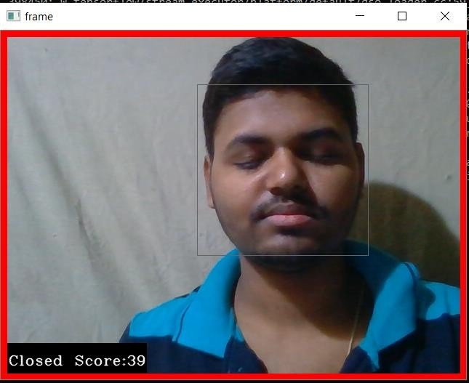

Note: Testing is performed manually.

# Chapter 7

## Project Planning

7.1 SYSTEM MODEL

The framework is created utilizing the incremental model. The center model of the framework is first created and afterwards augmented in this way in the wake of testing at each turn. The underlying undertaking skeleton was refined into expanding levels of ability.

At the following incremental level, it might incorporate new execution backing and improvement.

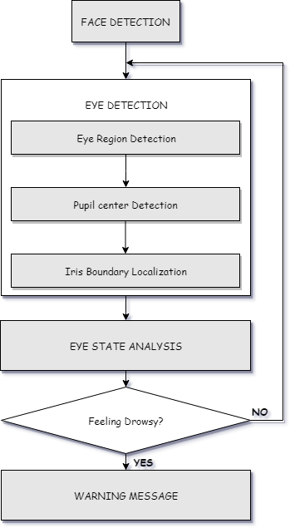

Figure 4: Block diagram

# Chapter 8

## Driver Drowsiness Detection System

###### About the Python Project

In this Python project, we will be using OpenCV for gathering the images from webcam and feed them into a Deep Learning model which will classify whether the person’s eyes are ‘Open’ or ‘Closed’. The approach we will be using for this Python project is as follows:

Step 1 – Take image as input from a camera.

Step 2 – Detect the face in the image and create a Region of Interest (ROI). Step 3 – Detect the eyes from ROI and feed it to the classifier.

Step 4 – Classifier will categorize whether eyes are open or closed. Step 5 – Calculate score to check whether the person is drowsy.

###### The Dataset

The dataset used for this model is created by us. To create the dataset, we wrote a script that captures eyes from a camera and stores in our local disk. We separated them into their respective labels ‘Open’ or ‘Closed’. The data was manually cleaned by removing the unwanted images which were not necessary for building the model. The data comprises around 7000 images of people’s eyes under different lighting conditions. After training the model on our dataset, we have attached the final weights and model architecture file “models/cnnCat2.h5”.

Now, you can use this model to classify if a person’s eye is open or closed.

## The Model Architecture

The model we used is built with Keras using Convolutional Neural Networks (CNN). A convolutional neural network is a special type of deep neural network which performs extremely well for image classification purposes. A CNN basically consists of an input layer, an output layer and a hidden layer which can have multiple numbers of layers. A convolution operation is performed on these layers using a filter that performs 2D matrix multiplication on the layer and filter.

The CNN model architecture consists of the following layers:

* + - Convolutional layer; 32 nodes, kernel size 3
    - Convolutional layer; 32 nodes, kernel size 3
    - Convolutional layer; 64 nodes, kernel size 3
    - Fully connected layer; 128 nodes

The final layer is also a fully connected layer with 2 nodes. In all the layers, a Relu activation function is used except the output layer in which we used Softmax.

## Algorithm

##### Step 1 – Take Image as Input from a Camera

With a webcam, we will take images as input. So to access the webcam, we made an infinite loop that will capture each frame. We use the method provided by

OpenCV, **cv2.VideoCapture(0)** to access the camera and set the capture object (cap). **cap.read()** will read each frame and we store the image in a frame variable.

##### Step 2 – Detect Face in the Image and Create a Region of Interest (ROI)

To detect the face in the image, we need to first convert the image into grayscale as the OpenCV algorithm for object detection takes gray images in the input. We don’t need color information to detect the objects. We will be using haar cascade classifier to detect faces. This line is used to set our classifier **face = cv2.CascadeClassifier**(‘ path to our haar cascade xml file’). Then we perform the detection using **faces = face.detectMultiScale(gray).** It returns an array of detections with x,y coordinates, and height, the width of the boundary box of the object. Now we can iterate over the faces and draw boundary boxes for each face.

for (x,y,w,h) in faces:

**cv2.rectangle(frame, (x,y), (x+w, y+h), (100,100,100), 1 )**

##### Step 3 – Detect the eyes from ROI and feed it to the classifier

The same procedure to detect faces is used to detect eyes. First, we set the cascade classifier for eyes in **leye** and **reye** respectively then detect the eyes using **left_eye = leye.detectMultiScale(gray)**. Now we need to extract only the eyes data from the full image. This can be achieved by extracting the boundary box of the eye and then we can pull out the eye image from the frame with this code.

l_eye = frame[ y : y+h, x : x+w ]

**l_eye** only contains the image data of the eye. This will be fed into our CNN classifier which will predict if eyes are open or closed. Similarly, we will be extracting the right eye into **r_eye**.

##### Step 4 – Classifier will Categorize whether Eyes are Open or Closed

We are using [CNN](https://en.wikipedia.org/wiki/Convolutional_neural_network) classifier for predicting the eye status. To feed our image into the

model, we need to perform certain operations because the model needs the correct dimensions to start with. First, we convert the color image into grayscale using **r_eye = cv2.cvtColor(r_eye, cv2.COLOR_BGR2GRAY)**. Then, we resize the image to 24*24 pixels as our model was trained on 24*24 pixel images **cv2.resize(r_eye, (24,24))**. We normalize our data for better convergence **r_eye = r_eye/255** (All values will be between 0-1). Expand the dimensions to feed into our classifier. We loaded our model using **model = load_model(‘models/cnnCat2.h5’)** . Now we predict each eye with our model

lpred = model.predict_classes(l_eye).

If the value of lpred[0] = 1, it states that eyes are open, if value of lpred[0] = 0 then, it states that eyes are closed.

##### Step 5 – Calculate Score to Check whether Person is Drowsy

The score is basically a value we will use to determine how long the person has closed his eyes. So if both eyes are closed, we will keep on increasing score and when eyes are open, we decrease the score. We are drawing the result on the screen using cv2.putText() function which will display real time status of the person.

cv2.putText(frame, “Open”, (10, height-20), font, 1, (255,255,255), 1, cv2.LINE_AA )

A threshold is defined for example if score becomes greater than 15 that means the person’s eyes are closed for a long period of time. This is when we beep the alarm using **sound.play()**

# Chapter 9

## Screenshots of Project

#### Awaken Person:



Open eyes state

#### Sleeping Person:



Close eyes state

# Chapter 10

## Conclusion and Future Scope

* 1. Conclusion

It completely meets the objectives and requirements of the system. The framework has achieved an unfaltering state where all the bugs have been disposed of. The framework cognizant clients who are familiar with the framework and comprehend it's focal points and the fact that it takes care of the issue of stressing out for individuals having fatigue-related issues to inform them about the drowsiness level while driving.

* 1. Future Scope

The model can be improved incrementally by using other parameters like blink rate, yawning, state of the car, etc. If all these parameters are used it can improve the accuracy by a lot.

We plan to further work on the project by adding a sensor to track the heart rate in order to prevent accidents caused due to sudden heart attacks to drivers.

Same model and techniques can be used for various other uses like Netflix and other streaming services can detect when the user is asleep and stop the video accordingly. It can also be used in application that prevents user from sleeping.

## References

* + 1. COMPUTATIONALLY EFFICIENT FACE DETECTION; B. SCHLKOPF-A. BLAKE, S. ROMDHANI, AND P. TORR.
    2. USE OF THE HOUGH TRANSFORMATION TO DETECT LINES AND CURVES IN PICTURE; R. DUDA AND P. E. HART.
    3. JAIN, “FACE DETECTION IN COLOR IMAGES; R. L. HSU, M. ABDEL- MOTTALEB, AND A. K. JAIN.
    4. OPEN/CLOSED EYE ANALYSIS FOR DROWSINESS DETECTION;

P.R. TABRIZI AND R. A. ZOROOFI.

* + 1. <http://ncrb.gov.in/StatPublications/ADSI/ADSI2015/chapter1A%20traffic>

%20accidents.pdf

[6] http://www.jotr.in/text.asp?2013/6/1/1/118718

[7] <http://dlib.net/face_landmark_detection_ex.cpp.html>